How to change Wireless Settings using smartphone or PC?
Step 1: Open the browser and input plc.tendawifi.com in address bar to login setup page. By default, password is “admin”.
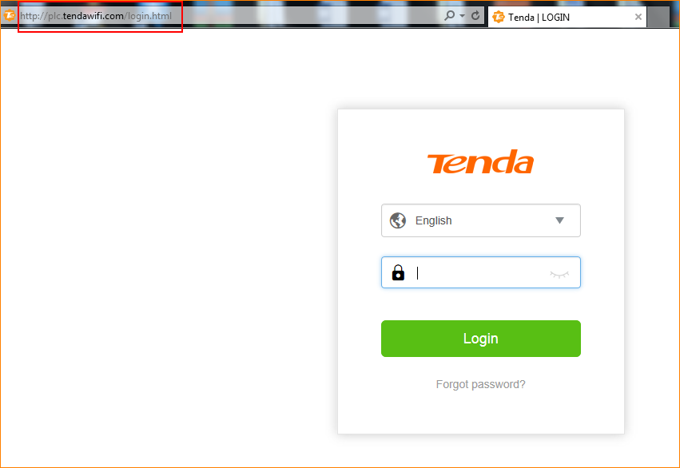

Step 2: You can change “Security Mode”.
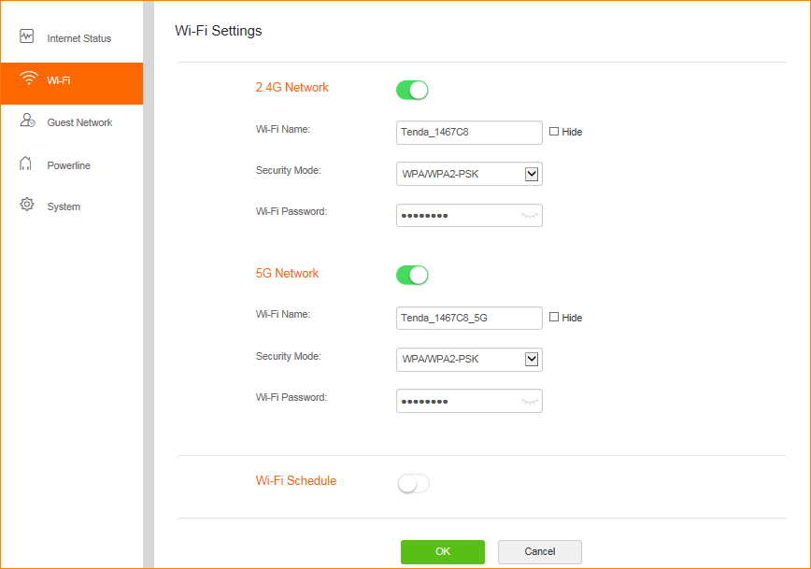

Step 3: You can set Channel & bandwidth & Network Mode. Please tap “OK” to save settings.
